Getting an Azure Account

1. Open a browser and go to <https://azure.microsoft.com/en-us/free/students-starter-faq/>

Click on the button

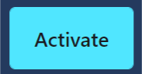

The Sign In page will appear.

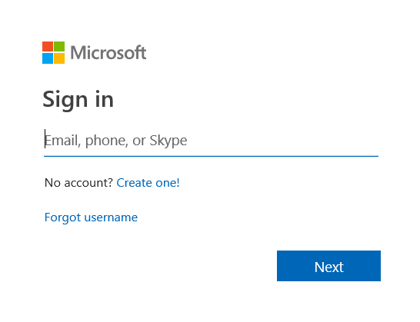

1. Sign In using your myrp.sg email address. After you have signed in, fill up the relevant details and click on the “Sign Up” button.
2. Check your school’s email for an email like below:

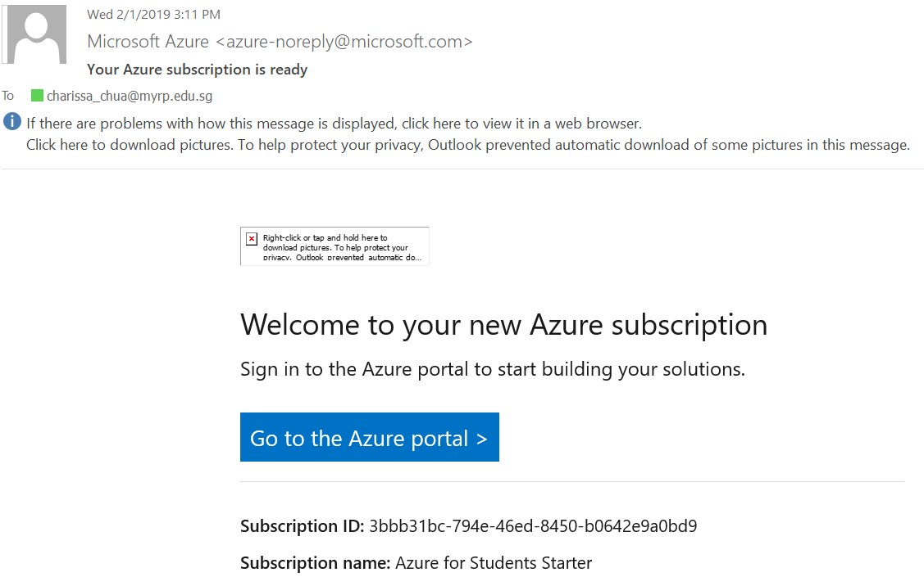

1. Click on the “Go to the Azure portal” button.